TABLES

1. FILEDETAILS

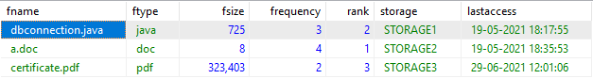

1. SHAREDETAILS

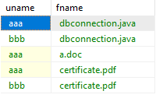

1. USER

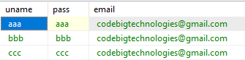

DATA TYPES

FILEDETAILS

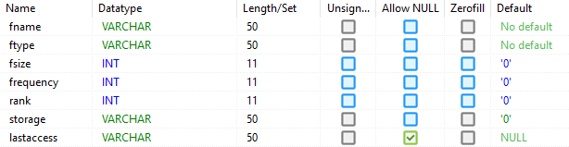

SHAREDETAILS

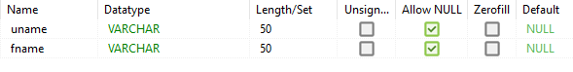

USER

